Download MySql Community Edition

<http://dev.mysql.com/downloads/mysql/>

You'll have to sign up for an Oracle ID.

Then Download the WorkBench

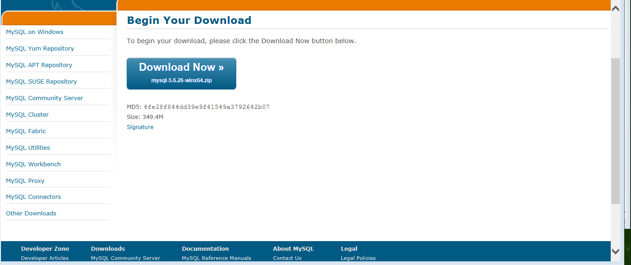

Then Download the connectors; may as well as download all since we’re still experimenting on languages.

Open WorkBench

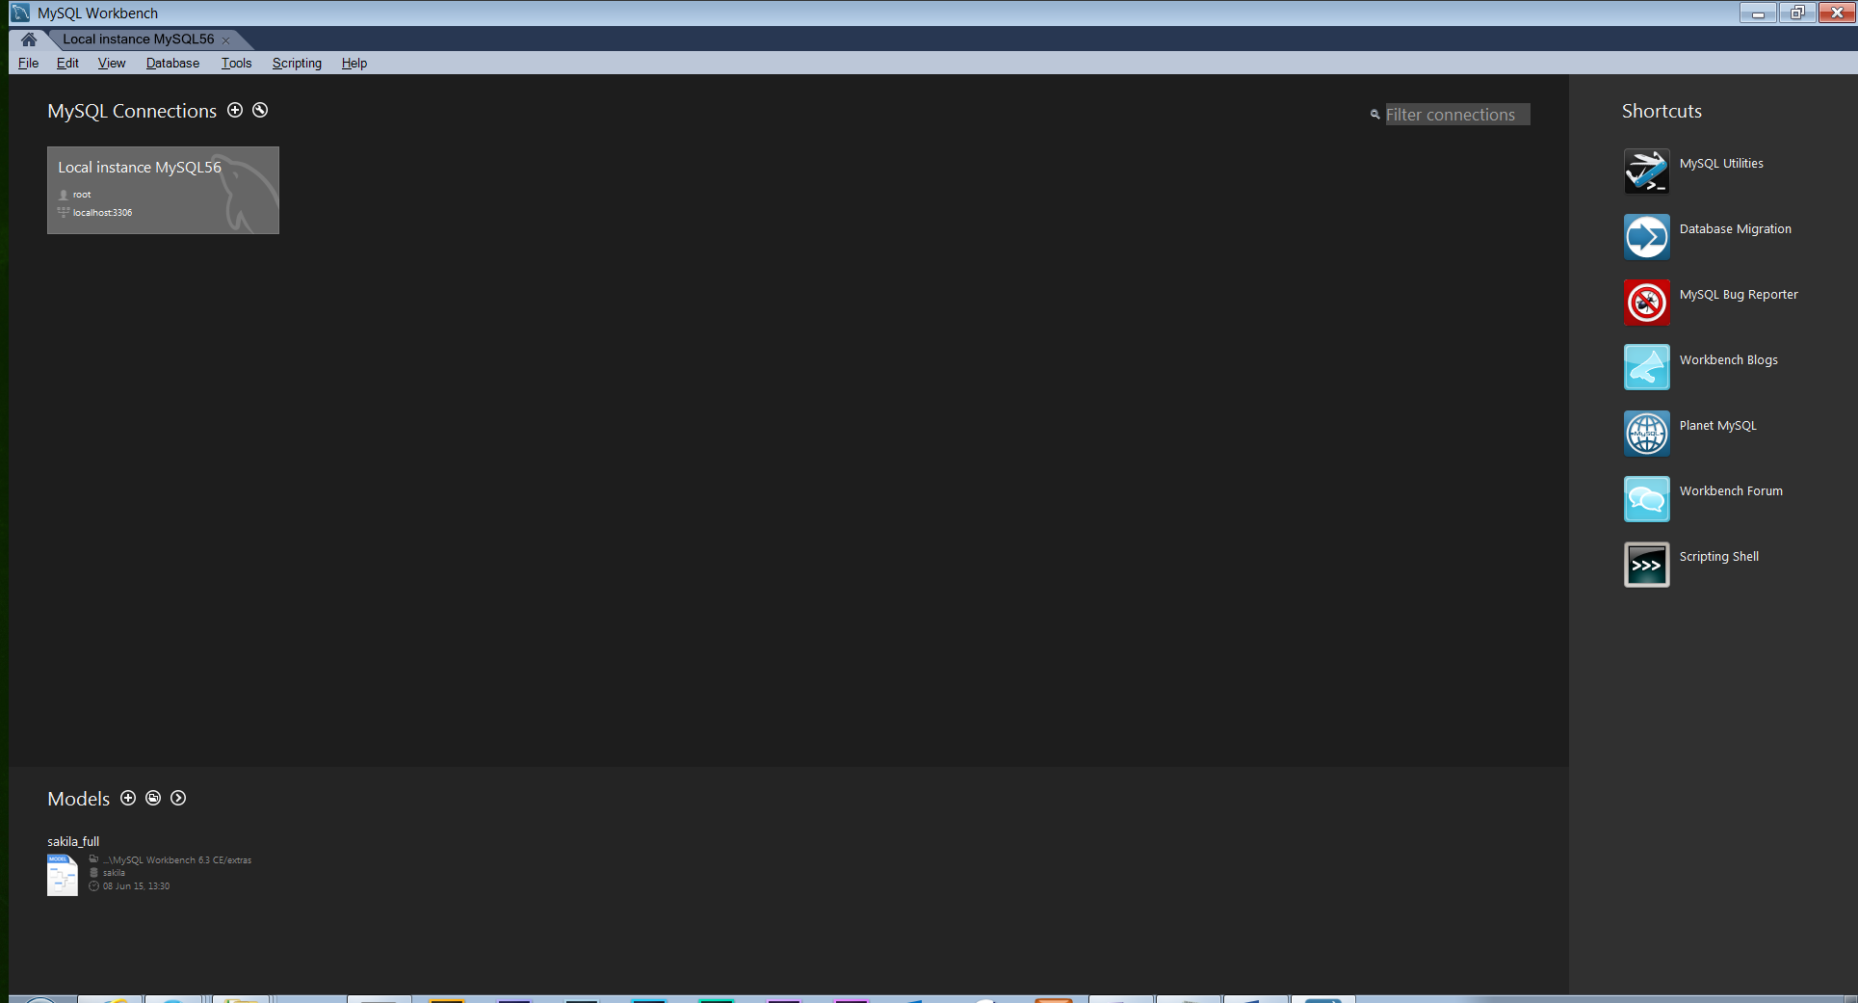

Click on the local server

Click on File->open

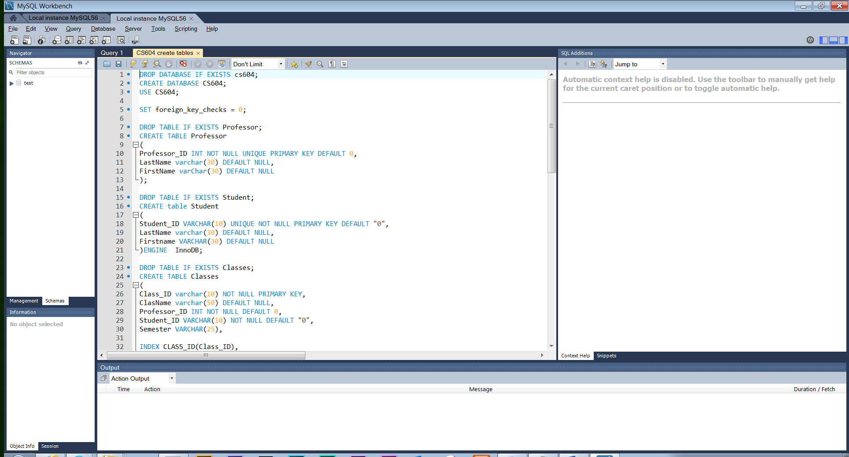

Navigate to where you stored the sql file “CS604 create tables.sql” is located. Under Query select run query. The database and tables should be created.

If you run it again it will just recreate the tables.

I’m probably going to change the schema, because I don’t like the layout and relation of the ClassDates table; may split it into two different ones.